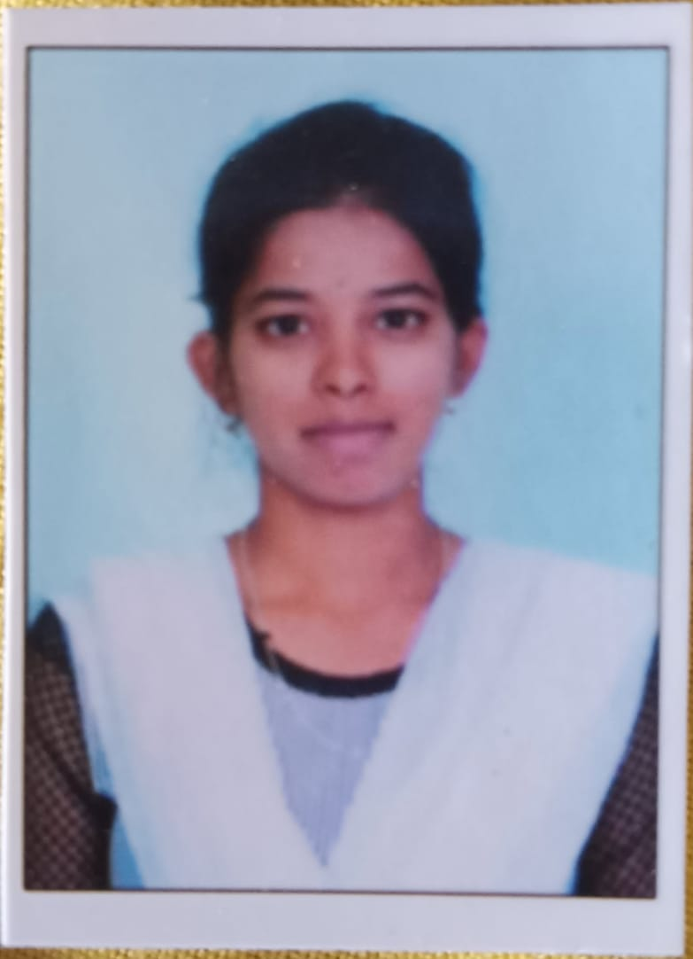
GANDLA ASWINI
Email-id: aswinigandla86@gmail.com
Contact No: 9391403949
CAREER OBJECTIVE:
To pursue a challenging career and to show the best of my professional ability skills and techniques to enhance my knowledge and growth in the Organization.
EDUCATION:
Degree | Year of Passing | School/Institute | Board /University | Percentage
B. Tech | 2026  (Pursuing) | Annamacharya institute of technology and sciences,Rajampet | Jawaharlal Nehru Technological University, Anantapur | 87.4%
Intermediate | 2022 | Sri Chaitanya junior college,Tirupati | Board of Intermediate Education, Andhra Pradesh | 91.3%
SSC | 2020 | Z.P.high school,puleru | Board of Secondary School Education, Andhra Pradesh | 98%

TECHNICAL SKILLS:
- Basics of C language
- Basics of core java
- Basics of python
SOFT SKILLS:
1.Smart working with positive attitude
2.Ability to stay focused & multitasking skills
3.Fast learner
4.Time management

INTERNSHIPS:
- Advanced data science
- Embedded system with IOT

CERTIFICATIONS:
- Data Science-EDX
- Java programming: Object Oriented Design -EDX
- Internet Of Things (IoT) – NPTEL
- Introduction to Industry 4.0 and Industrial Internet Of Things – NPTEL

HONORS & AWARDS:
- Won certificate for securing first place in the shuttle competition
- Antrix association member certificate
- Merit certificate of NPTEL

PERSONAL DETAILS:
- Father’s name: G.CHINNA NARASIMHAIAH
- Date of birth: 22/02/2005
- Linguistic proficiency: English, Telugu
- Hobbies: Reading books, Listening Music, Playing games.

REFERENCE:
- J. Chinna Babu
ASSOCIATE PROFESSOR
ANNAMACHARYA INSTITUTE OF TECHNOLOGY AND SCIENCES
RAJAMPET
9848036672

Declaration:
I hereby declare that the information furnished above is true to the best of my knowledge.

G.Aswini
Location: Rajampet Signature

